Job Market Analysis

1. Project Overview
This project focuses on analyzing job market data to understand hiring trends, required skills, salary distribution, and job availability across different locations. The goal is to convert raw and unstructured job data into meaningful insights that can help students and job seekers make better career decisions.

2. Dataset Summary
- The dataset contains job-related information such as:
  - Job Title
  - Company
  - Location
  - Salary
  - Experience Required
  - Skills
  - Job Type
  - Rating
- Issues in dataset:
  - Missing values (Salary, Skills, Job Title, Rating)
  - Inconsistent formats (e.g., “6 LPA”, “600000”, “6 lpa”)
  - Duplicate entries
  - Multiple skills in a single column

3. Data Cleaning & Structuring (Excel)
The raw dataset was first cleaned and structured using Microsoft Excel.
Steps performed:
- Handled missing values:
  - Filled missing salary using average salary
  - Filled missing job titles and skills using appropriate values
- Standardized Salary:
  - Converted salary formats like “₹6 LPA”, “6 lpa” into numeric values (600000)
- Removed duplicates:
  - Identified and removed repeated job entries
- Cleaned text data:
  - Converted job titles to consistent format (e.g., “Data Analyst”)
- Structured Skills column:
  - Prepared data for further analysis
This step ensured the dataset was clean, consistent, and ready for analysis.

4. Data Analysis using Python (Google Colab)
After cleaning, the dataset was analyzed using Python in Google Colab with the Pandas library.
Steps performed:
- Loaded dataset using pandas
- Checked dataset structure using df.info() and df.describe()
Analysis performed:
- Job Role Demand
  - Counted number of jobs per role
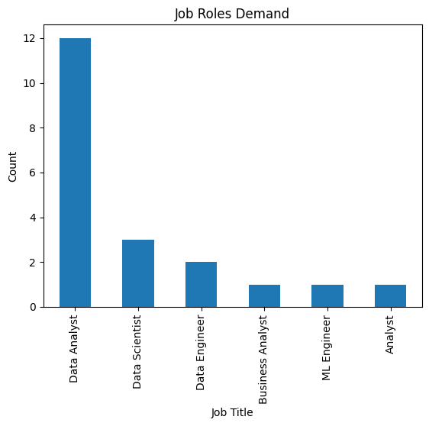
- Salary Analysis
  - Calculated average and maximum salary
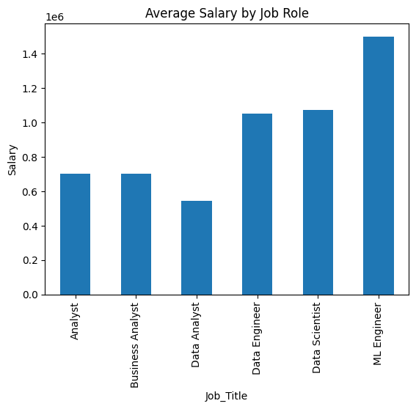
- Top Skills Analysis
  - Split skills and analyzed most frequently required skills
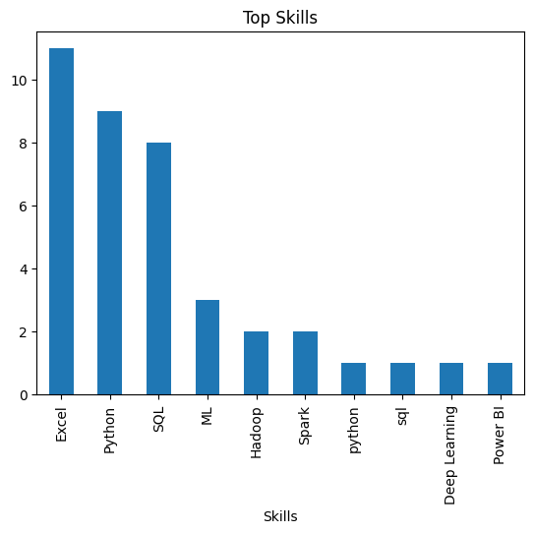
- Location Analysis
  - Counted jobs available in each city
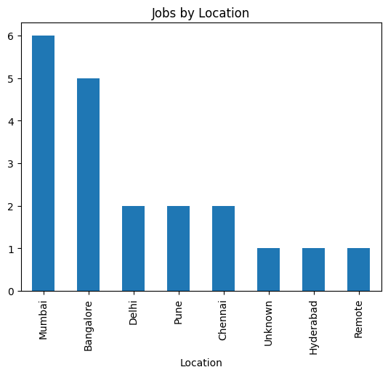
- Job Type Analysis
  - Compared Full-time, Internship, and Contract roles
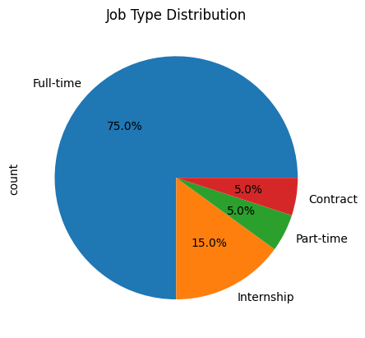

5. Dashboard in Power BI
An interactive dashboard was created in Power BI to visualize the insights.
Dashboard includes:
- KPI Cards
  - Total Jobs
  - Average Salary
  - Maximum Salary
- Visualizations
  - Job Role Demand (Bar Chart)
  - Average Salary by Job Role
  - Top Skills by Count
  - Jobs by Location
  - Job Type Distribution
- Filters (Slicers)
  - Location
  - Job Type
  - Job Title
The dashboard allows users to interact with the data and explore trends easily.
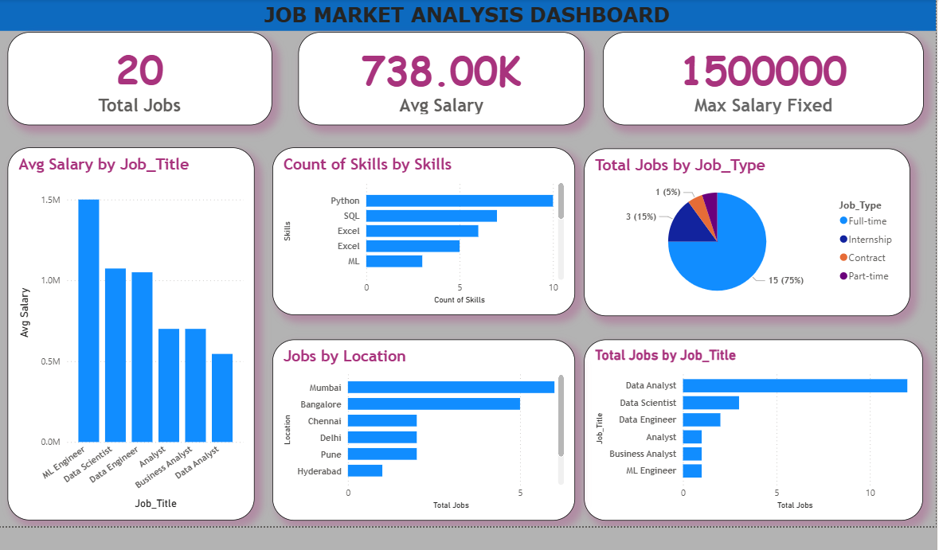

6. Key Insights
- Data Analyst is the most in-demand job role
- Python, SQL, and Excel are the most required skills
- Bangalore and Mumbai have the highest number of job opportunities
- Machine Learning roles offer higher salaries
- Full-time jobs are more common than internships

7. Real-World Application
- Helps students understand which skills to learn
- Assists job seekers in choosing the right job roles
- Helps companies understand hiring trends
- Supports better decision-making using data

8. Conclusion
This project demonstrates how raw job data can be cleaned, analyzed, and visualized to generate meaningful insights. By using Excel for data cleaning, Python for analysis, and Power BI for visualization, the project provides a complete end-to-end solution for job market analysis.

